NICU Routine Intubation Guideline with IV Access

Recommended Population
- All neonates with IV access in NICU
- Select patients in delivery room (congenital heart disease) when IV access is feasible.

Not recommended
- Patients without IV access where immediate intubation is needed (most delivery room intubations)
- Critical airways or concern for unable to provide effective PPV (relative contradiction, case-by-case)
- INSURE, TCA, and SALSA procedures

Equipment
- Suction and stethoscope
- Oxygen and device to provide CPAP and PPV (Neo-Tee or flow-inflating bag)
- Airway (ETT) and stylet
- Pedi-Cap
- Tape
- Neck roll (if indicated)
- Back-up laryngeal mask airway
- Laryngoscope (video preferred)

Medications ("NICU intubation" in Epic orders)

Vagolytic (Atropine 0.02mg/kg) IV
Analgesic (Fentanyl 2mcg/kg) IV
Paralytic (Rocuronium 1mg/kg) IV

Emergency paralytic reversal agent (available in both NICUs):
Sugammadex 4 mg/kg IV

Sample Roles (discuss roles and positions prior to intubation)

Intubating provider
Holds mask during CPAP/PPV
Laryngscopy and ETT placement

Leader
Performs Checklist
Assigns Roles
Leads procedure
Coaches intubating provider

RT
Prepares CMAC or Neoview, ETTs, and Pedi-Cap
Sets up PPV device (appropiate PIP/PEEP for patient)
Gives inflations during PPV
Passes ETT to intubating provider

RN1
Draws up and administers premedications
Prepares tape and secures ETT

RN2
Recorder
Assists with securing ETT

Procedure

1) Perform Time-out and Checklist

2) Remove Non-invasive support. Intubating provider applies CPAP via Neo-tee/flow inflating bag with 2 hands. Assess for appropriate mask fit and check the manometer to ensure the set PEEP is being delivered.

3) Consider oropharyngeal suction to clear secretions

4) Leader announces "administer premedications"

5) RN Administers Medications
1st push: Vagolytic (Atropine 0.02mg/kg) IV
2nd push: Analgesic (Fentanyl 2mcg/kg) IV
3rd push: Paralytic (Rocuronium 1mg/kg) IV
4th push: Rapid flush (0.5-1mL normal saline) IV

6) When patient becomes apneic, RT begins PPV (flow inflating bag or Neo-Tee)
7) Monitor for chest rise. If no chest rise, perform MR-SOPA.
8) Intubating provider performs laryngoscopy; leader providers coaching
9) When vocal cords identified, assistant (RT/RN/leader) hands ETT to intubating provider
10) Intubating provider advances ETT through vocal cords
11) RT attaches Pedi-Cap and PPV device to ETT
12) Adjust ETT to 6cm + wt (kg) at the gums. Secure ETT.

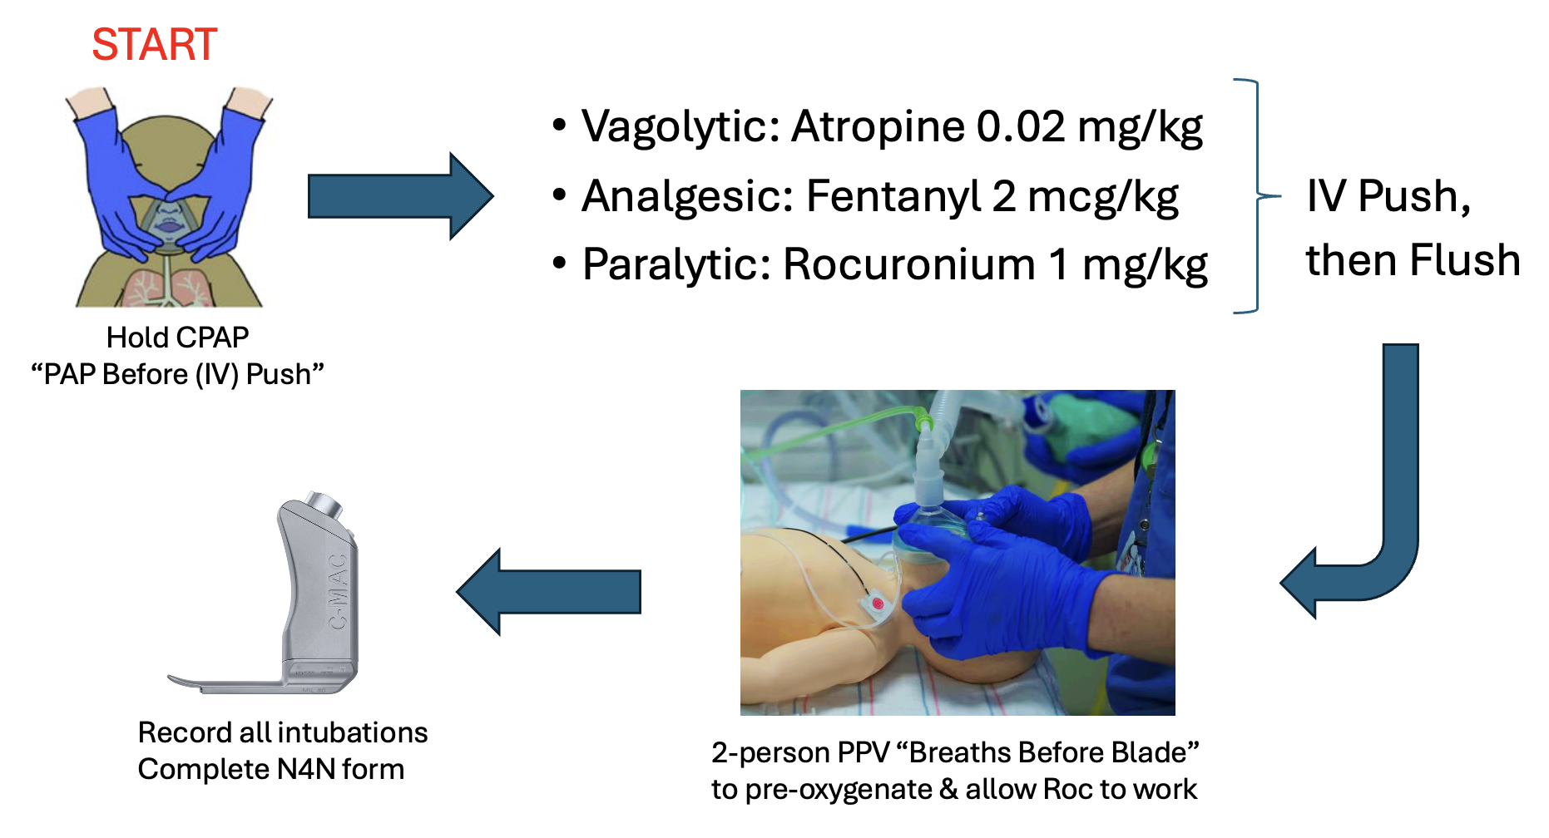

Post-Procedure
- Obtain X-ray and blood gas
- Discuss ventilator settings with RT
- Perform debrief (discuss what went well and areas for improvement)

Documentation:
- Medical provider to complete procedure note in EPIC and complete NEAR4NEOS QI form

