NAVA (Neurally Adjusted Ventilatory Assist) Guidelines (December 16, 2025)

  - NAVA delivers assisted breaths in proportion to and in synchrony with the baby’s respiratory efforts, specifically depolarization of the diaphragm using the electrical signal picked up by the NG/OG tube via the Edi (electrical activity of the diaphragm) catheter.
  - A low or absent Edi signal may be due to hyperventilation, sedation, muscle relaxants, neural disorders, or the catheter being too deep.
  - Edi max = force of the diaphragm contraction during inspiration
  - Edi min = force required to maintain FRC at the end of exhalation
  - Peak Pressure = NAVA level x (Edi peak – Edi Min) + PEEP
  - Contraindications: insufficient/absent respiratory effort, anomaly (esophageal atresia, unrepaired CDH), phrenic nerve injury, congenital myopathy, MRI scanning (remove catheter before scan)
  - NAVA is provided via Servo-U ventilators
  - Can be used for either invasive or non-invasive ventilation

Considerations:

  - Struggling to wean utilizing traditional ventilator approaches
  - Babies with heterogenous lung disease may benefit from more intrinsic breathing control
  - Babies with established BPD (bronchopulmonary dysplasia)
  - Extubation modality for babies who would benefit from increased ventilatory support than CPAP
  - Babies with frequent apneic spells

NAVA General Information:

  - NIV-NAVA delivers synchronized variable PS to non-intubated patients with RDS/BPD to
minimize the need for reintubation by decreasing the work of breathing (noninvasive ventilation).
  - NIV-NAVA delivers back-up respiratory support to treat episodes of desaturations and bradycardia from alveolar hypoventilation secondary to apnea via activation of a set back-up rate (e.g., to treat central apnea of prematurity).
  - NIV-NAVA is used primarily in premature infants for respiratory support after extubation with RDS, BPD and/or apnea of prematurity.
  - Infants set their own IT and Rate for each NAVA breath
  - NAVA delivers variable PS which is proportional to diaphragmatic activity.
  - NAVA functions as a form of proportionally assisted ventilation based on the degree of lung disease (work of breathing).
  - The PIP delivered by NAVA during the NAVA breath will vary with every breath, but again, the starting PIP range should reach into the twenties (cm H₂O).
  - Always obtain an initial CXR (down to the umbilicus) after placing on NAVA to assess lung expansion and proper placement of the Edi catheter tip in the stomach without the tip pushing on the gastric wall.

Suggested Settings and Management Strategies:

 | Initial Settings | Range  (Suggested Minimum & Maximum) | Adjust by
NAVA Level  (optimize NAVA level according to Edi Max) | 1-2 cm H₂O/µV | 0.5cm H₂O/µV-4-6 cm H₂O/µV  Do not use NAVA <1 for intubated patients | 0.1-0.2 cm H₂O/µV
PEEP, cm H₂O | 6-8 cm H₂O (same or one higher than ventilator settings. Adjust based on gases and x-ray) | Max 14 cm H₂O  Consideration to be given based on interface | 1cm H₂O
Consider increasing PEEP when transitioning from invasive to NIV NAVA to maintain adequate MAP
Edi Goal:  Minimum: 2-4 µV  Target: 10-15µV) |  | - For Edi Max >15µV, increase NAVA level.  - If Edi Max <10µV decrease NAVA level  - If Edi min >5µV increase PEEP  - If Edi Min too low Decrease PEEP

Backup Settings
 | Initial Settings | Range  (Suggested Minimum & Maximum) | Adjust by
Backup pressure control above PEEP | 10-15 cm H₂O | Max 30-35cm H₂O  (or per physician discretion) | 1-2cm H₂O
Rate | 30-40/min | Max of 60/min | As needed
Inspiratory Time | 0.3-0.5 seconds | 0.3-0.7 seconds | 0.05-0.1 seconds
Apnea Time | 2-3 seconds | 2-15 seconds | 1-2 seconds
Trigger Sensitivity | 1-2 |  | -
High-pressure alarm | 40-50cm H₂O  (or higher as needed) |  | -

Adjust NAVA level only when Edi peaks/mins remain outside the target range for at least one hour, using trend data to avoid frequent changes that may destabilize the infant. Obtain x-ray every time NAVA catheter is replaced

(adapted from Ramanathan and Biniwale, Crit Care Nurs Clin North Am. 2024 Mar;36(1):51-67)

  - Wean NAVA if pCO₂ too low (e.g., < 40 in a patient with apnea or < 55 in a patient with BPD)
  - Increase NAVA if pCO₂ too high (e.g., > 65-70 or increased work of breathing).

If frequent backup ventilation is occurring, consider:
  - Increasing NAVA level to support spontaneous efforts
  - Reducing apnea time if the baby is having prolonged pauses
  - Ensuring proper Edi catheter placement
Guidance for transitioning from invasive to non-invasive NAVA (and vice versa):
  - Increase PEEP when transitioning from invasive to NIV NAVA by 1-2 cm H₂O
  - Increase NAVA level by 0.5-1 H₂O/µV
  - Monitor the Edi peak and tidal volume after transition to titrate the NAVA level.
  - The goal is to maintain a similar work of breathing and adequate ventilation while ensuring comfort and synchrony.
Back-up Settings for Apnea of prematurity on NIV-NAVA(additional points):
- NIV-NAVA aims to avoid excessive backup ventilation, as spontaneous breathing is preferred.
- Apnea Time: 2–5 seconds
  - Shorter for more immature infants (e.g., 2–3 sec for ELBW infants)
  - Slightly longer for more mature preemies (e.g., 4–5 sec)
- Backup Rate: 40–60 breaths per minute (bpm)
  - Set based on the infant’s typical spontaneous respiratory rate
- Inspiratory Time (I-time): 0.3–0.4 sec
  - Shorter for extremely preterm infants (~0.3 sec)
  - Slightly longer (~0.35–0.4 sec) in more mature preemies
- Peak Inspiratory Pressure (PIP): Appropriate for patient size
  - Typically 15–20 cmH₂O, but may vary based on lung mechanics
  - Avoid excessive pressure to prevent overdistension
- PEEP (Positive End-Expiratory Pressure): 5–7 cmH₂O
  - Helps maintain lung recruitment and prevent atelectasis
- FiO₂ (Oxygen Setting): Titrate to maintain SpO₂ goals
  - Usually set to match pre-apnea FiO₂, with adjustments as needed
Key Considerations:
Apnea Time (Apnea Delay):
  - Start with 2-3 seconds then increase by 2-5 seconds as apnea resolves.
  - Only increase after infant is having minimal to no spells requiring nursing intervention for bradycardia or desaturations.
  - Increase the apnea time delay incrementally over days to weeks depending on the level of maturity of the patient until reaching a 15 second delay and apnea of prematurity has improved.
  - Can maintain at 15 seconds if the patient still requires NAVA support for lung disease or if no need for NAVA and without significant spells for at least 24 - 48 hours, can wean to Nasal CPAP.
  - Wean by increasing the apnea delay alarm as described above.
  - If after increasing the apnea delay, the patient starts requiring frequent tactile stimulation by nursing to resolve the A/B/D spell then lower the apnea time delay back to the previous setting so that the back-up rate is initiated sooner to prevent bradycardia and desaturations from apnea.

Troubleshooting:
- If the patient continues to have bradycardia and desaturations requiring frequent tactile stimulation by nursing to resolve spells: consider increasing the backup PIP and inspiratory time (IT), and decreasing the apnea time (ideally not < 2 seconds).
- If increased backup support fails to prevent bradycardia and desaturations due to central apnea: consider reintubation and evaluate for other causes of central apnea, particularly sepsis.
- Overventilation: When weaning, remember to decrease backup settings!
- Respiratory Failure: If Edi-min is low, this may indicate respiratory failure rather than readiness to wean.
- Shallow Breathing:
  - Consider increasing or decreasing the Edi trigger.
  - Consider environmental influences on the catheter.
Post-Extubation Support for Mature Patients with BPD (Minimal Concerns for Apnea):
- NAVA settings (cm/μV) used in the management of BPD/CLD will be significantly higher than those needed for apnea of prematurity due to underlying lung disease.
Apnea Time Delay for Mature BPD Patients:
- Start with 5 seconds, and increase by 5-second increments over days.
- Increase the delay time after at least 24–48 hours without significant spells (requiring nursing intervention to resolve), up to a maximum of 15 seconds. Maintain this until the patient is ready for nasal CPAP.
- Central apnea is usually not the primary issue in these patients.
- Wean NAVA support gradually over days to weeks as lung disease, work of breathing, and/or blood gases improve.
- Once on a NAVA level of 1–2 µV without triggering the apnea backup, consider weaning to nasal CPAP. Be sure to increase the CPAP level on the RAM cannula by 2 cm H₂O above the PEEP on NAVA to maintain similar delivered MAP (Gerdes JS, et al. Pediatr Pulmonology 2016;51:60 69).
- Adjust PEEP as needed based on oxygen requirements, lung expansion, and aeration on chest X-ray.
Important Points:
- Backup rate alarms sound during apnea but resolve automatically once the infant resumes spontaneous breathing—this is expected and appropriate.
- Backup ventilation activates only during apnea and may occur frequently in infants with central apnea until they mature.
- As long as there’s no desaturation or bradycardia requiring nursing intervention, the ventilator is functioning as intended.
- Use the Trends screen to assess the frequency and duration of backup rate use.
- If a vigorous infant frequently enters backup, consider increasing the apnea delay time.
- Edi peak range: typically 10–20 µV.
- If >20 µV with ↑ WOB → increase NAVA level by 0.2–0.5 µV until peaks return to teens.
- If <5 µV in a comfortable infant → consider weaning NAVA support.
- Edi minimum >5 µV with atelectasis on CXR → increase PEEP.
- NIV-NAVA must be delivered via dedicated nasal prongs or mask.
- RAM cannulas are not appropriate due to high resistance and poor volume delivery (Matlock DN et al., J Perinatol 2019; 39:723–729).
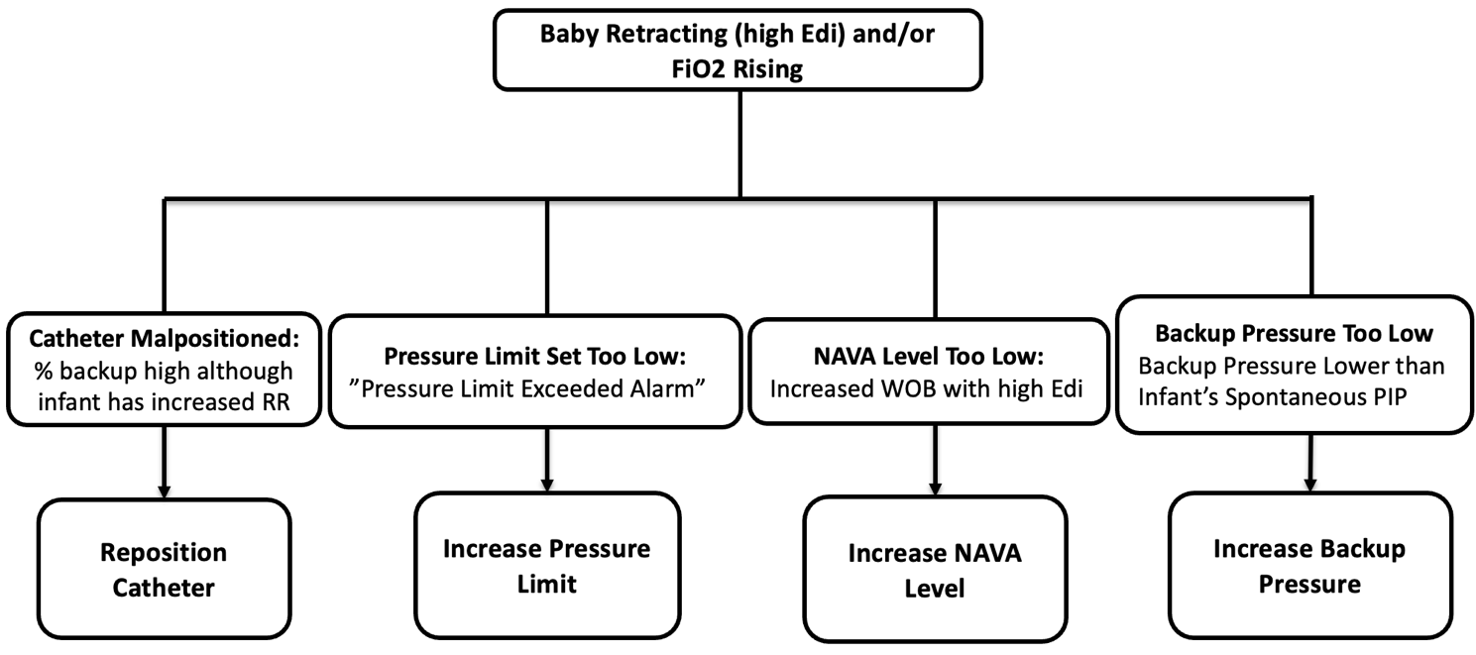

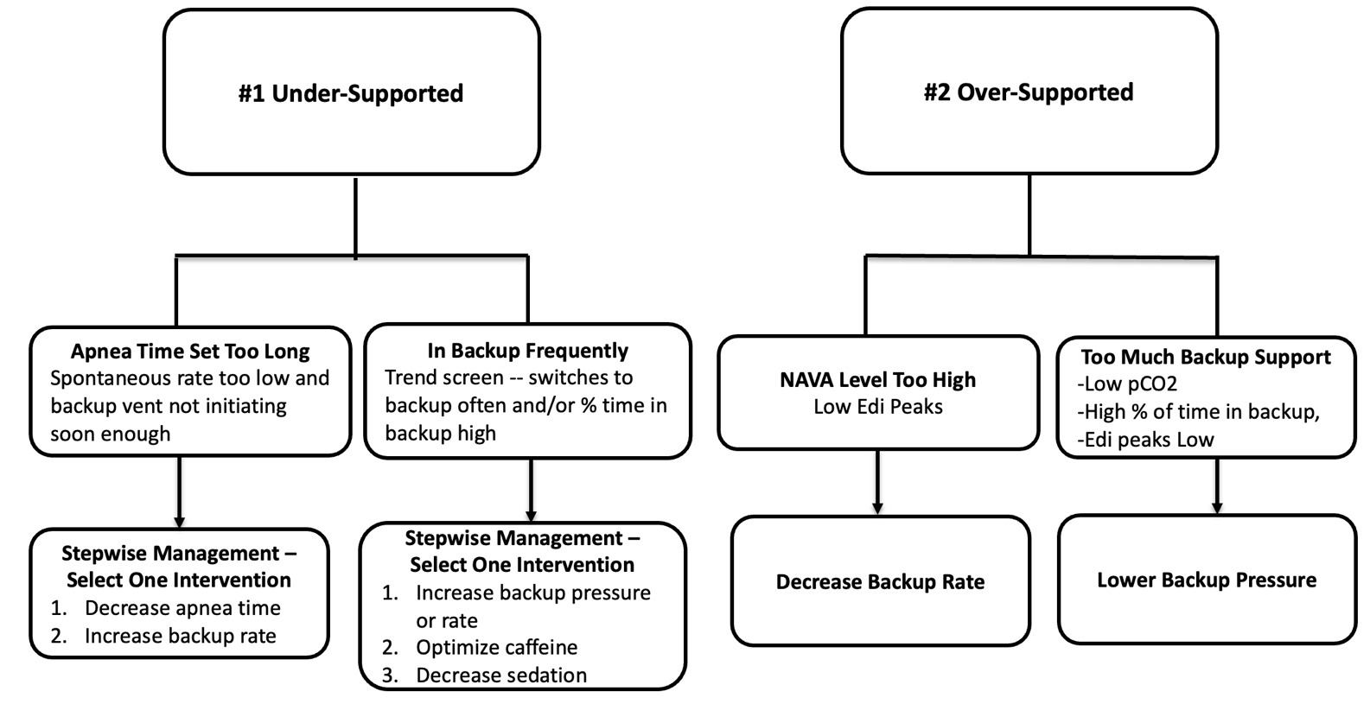

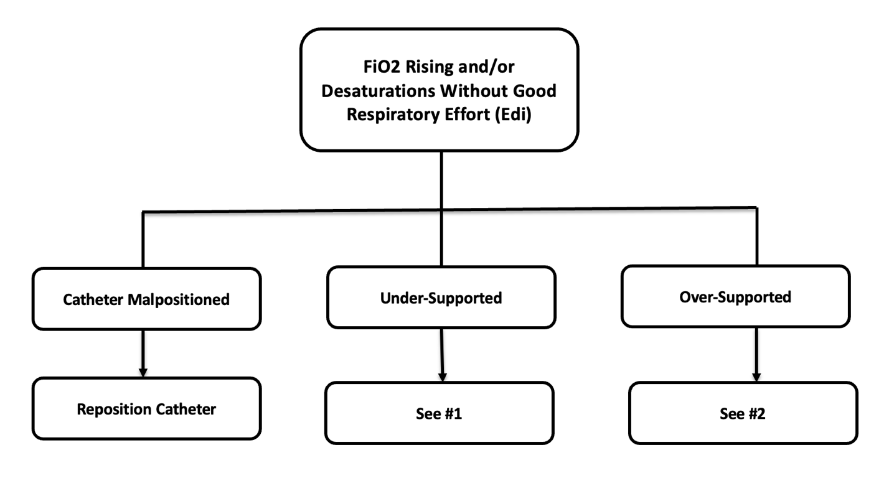

References:
  - Children’s Hospital of Iowa NAVA policy (Jonathan Klein M.D., and Denise Holida ARNP) written 2012, revised in 2016, and 2022
  - Matlock DN, Bai S, Weisner MD, Comtois N, Beck J, Sinderby C, Courtney SE. Tidal volume transmission during non-synchronized nasal intermittent positive pressure ventilation via RAM® cannula. J Perinatol. 2019 May;39(5):723-729. doi: 10.1038/s41372-019-0333-x. Epub 2019 Feb 12. PMID: 30755718.
  - Gerdes JS, Sivieri EM, Abbasi S. Factors influencing delivered mean airway pressure during nasal CPAP with the RAM cannula. Pediatr Pulmonol. 2016 Jan;51(1):60-9. doi: 10.1002/ppul.23197. Epub 2015 Apr 7. PMID: 25851534.
  - Ramanathan R, Biniwale M. Noninvasive Ventilation. Crit Care Nurs Clin North Am. 2024 Mar;36(1):51-67. doi: 10.1016/j.cnc.2023.11.001. Epub 2023 Nov 29. PMID: 38296376.
  - Stein H, Howard D. Neurally adjusted ventilatory assist in neonates weighing <1500 grams: a retrospective analysis. J Pediatr. 2012;160(5):786-9.e1. doi:10.1016/j.jpeds.2011.10.014
  - Stein, H. & Firestone, K. (2018). Neurally adjusted ventilatory assist (NAVA) in Neonates. In PK Rajiv et al. (1st Edition). Essentials of Neonatal Ventilation (227-237). Elsevier.

